Title
Metadata , DISTRICT BOUNDARIES

Description
ACT District boundaries

Data Currency
Current (the data is 24 hours old on the date of supply)

Maintenance and Update Frequency:
The SHP files are updated on a daily basis.
The Oracle spatial data base tables are maintained by the ACTMAP Data Manager on a daily basis.

Lineage
The data is extracted directly from the SDMS Oracle spatial data base tables using the Feature Manipulation Engine software (FME)

Positional Accuracy
The data in this file is not survey accurate
In the SHP file, arcs are represented by a number of line segments. The number of line segments is determined by the FME algorithm Douglas Line Generalizer with the tolerance value set at 0.003. This algorithm reduces the number of line segments created to represent arcs in the SHP file to an optimum level and keeps the SHP file to a reasonable size.

Attributes

Basic attribution is attached to the district polygon.

Attribute Accuracy
100% accurate representation of the known data

Completeness
The data reflects all known current data. The data base is a planning data base and contains approved and planned data as well as current data.

Stored Format
The data is stored in Arcview SHP format in ACT and MGA94/55 grid co-ordinates.

Access Constraints
The data is supplied for private and business use on the condition that the data may not be sold nor given to a third party without the written permission of the ACT Planning and Land Authority.

The full set of conditions, including acknowledgments, are outlined in the Licence Agreement.

Custodian
Australian Capital Territory
ACT Planning and Land Authority

Error reporting
Data Distribution Officer
GPO Box 1908
Canberra ACT 2601

Phone: (02) 6205 0066
Fax: (02) 6207 1615
Email: daniel.goodwin@act.gov.au

FILE DESCRIPTION

ACT_DIST ACT District boundaries
Attributes
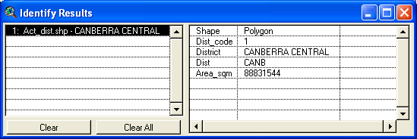

Attributes description

Dist_code Unique District ID

District District name
Dist District name short
Area_sqm Area in square metres

